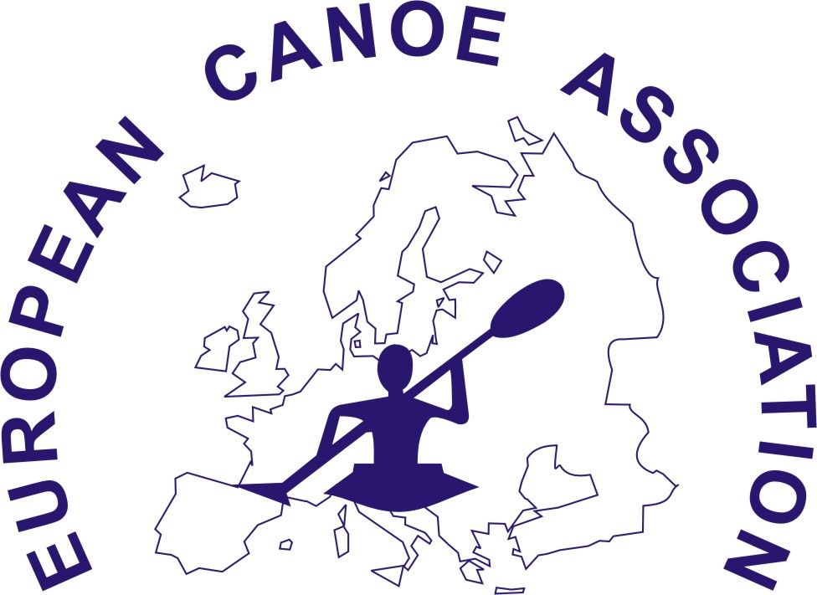

ECA PARACANOE
Waiver for strapping within boats
FEDERATION: ...........................................................
ATHLETE COMPETITION NUMBER: .......................
ATHLETE NAME: ...........................................................
I witness that I am able to quickly and easily release myself from any strapping which holds me in place in my boat, and I would be able to do so should my boat capsize at any time while I am on the water.
I will not hold the ECA, or the 2015 European Canoe Sprint Championship organizing committee, or any of their representatives, responsible for any harm or injury which may occur as a result of the use of strapping in my boat.

ATHLETE SIGNATURE: ...................................................

I witness that this athlete is able to quickly and easily release him/herself from the strapping in his/her boat should it capsize at any time while he/she is on the water. He/she is at no risk of personal harm or injury.
We will not hold the ECA or the 2015 European Canoe Sprint Championship organizing committee or any of their representatives responsible for any harm or injury which may occur to this athlete as a result of the use of strapping within his/her boat.

TEAM LEADER: .............................................................
(Please Print)

TEAM LEADER SIGNATURE: .........................................

